Making a Water Wheel
Read Pages 15/16 in your mini-textbook as a group. After reading, discuss these questions as a group:
- What FORCE is used to power water wheels?
- What types of things were water wheels used for in Canada?
- What are some advantages of using water wheels?
Materials
- 2 wooden sticks (axles)
- One cut up/ folded plastic container
- One plastic spool
- Many cut up plastic spoons
- Tape
- “Evaluating your Waterwheel” handout (one per student)
- A water bottle full of water and a bin to catch water (no wider than the axle length)
- Mini textbooks
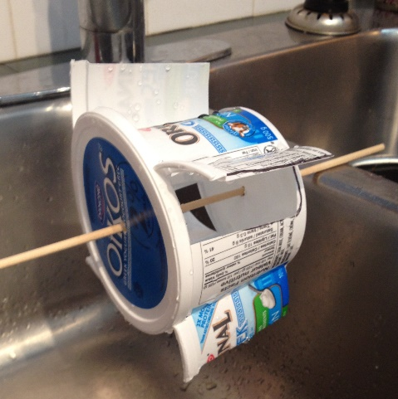
Test Device #1 (The plastic container that I have already made)
- Make sure that the lid is on the container very tight. Put one of the wooden sticks through the middle of the entire container so that the container can rotate around the axle like this
- Place the stick across the “catching” container. Each student can try pouring a bit of water on the waterwheel, seeing which strategies make it turn the fastest. For example, does it help to do lots of water pouring or just a little bit? Does it help to pour close to the container, or far away? PLEASE clean up any messes that you make!
- After testing waterwheel #1, get the worksheet called “Evaluating 2 Waterwheels” and fill in the first column for “waterwheel 1” with either a “yes” or a “no” for each question.
Build and test Waterwheel 2
Use the big black plastic spool, the small spoons, tape, and the other wooden stick to create your own waterwheel as a group. WORK TOGETHER! HINT: use the spoons as “paddles” that would turn the spool. If after a few minutes you can’t seem to make anything work, you can open the “HINT” envelope to see a picture example of one model that I have made. Good Luck!
After you have successfully build your own waterwheel as a team, test it out with water to make sure that it works. Fill in the rest of the worksheet called “Evaluating 2 Waterwheels”

Evaluating 2 Waterwheels NAME: ____________________
 | Waterwheel #1 | Waterwheel #2 | COMMENTS
Does it work like it is supposed to?
Does it work every time?
Does it stand up to repeated use?
Is it easy to build?
Is it easy to use?
Are there any risks in building or using it?
Can it be made cheaply?
Does it use recycled materials?
Can the materials be used for another project?
Draw a picture of your waterwheel below:
Based on the CRITERIA above, which waterwheel do you think was better and why?
__________________________________________ _______________________________________________________________________________________________________________________________________________________________________.

HINT CARD: Put these pictures in an envelope… make kids at least brainstorm their own solution before peeking at my model.
