Activity Name: Twitter enriched Novel Study
Grade: could be done with any grade really, but my “book” example and SLOs were pulled from grade 9 curriculum
Subject:English
Description of Activity: - NOTE this is more of a collection of activities, not just one!
I think that Twitter could be used as a way to “spice up” the traditional exercises of a novel study. Most novel studies include looking at character sketches and how they develop, relationships, symbolism, predicting, significant plot advances, setting, imagery, conflict, etc. Instead of developing small assignments to be put into something like a portfolio, you could give a series of assignments (like 1 or 2 a week) that focus on a topic that is important in that week’s reading (or chapter). Each week the teacher could tweet out a shortened version of the small assignment as a reminder, and at the end of the assigned week, you can look at the tweets together as a class as a review. Students would respond on Twitter with quotes, links, pictures, or other media you have asked them to incorporate into their post using that week’s hashtag. You could make a class hashtag such as #LOTFc1 (Lord of the Flies chapter 1), #TSBc3 (Touching Spirit Bear chapter 3) etc. so that you can easily find what chapter you were referring to each week and shouldn’t have interference from other unrelated tweets. By the end of the novel, each “focused weekly assignment” would help to put together all of the pieces of the whole novel, and it would all be documented for students to be able to easily refer back to. A benefit of doing small weekly assignments like this is that it is a way to ensure that students are following along, and for the teacher to monitor who is actively participating.

Examples of weekly questions might include things like:
Ch1 – Find or draw a picture that exemplifies good descriptive imagery in this first chapter. Try to find a picture that mirrors imagery you saw in your own mind while reading a particular line. Feel free to edit pictures to suit your vision more clearly. NO repeat pictures! Everyone must find a different picture! Quote the necessary descriptive part of the text, and then include the page number and our hashtag for this week #TSBc1
Possible Student Examples that they might tweet from ch. 1 of Touching Spirit Bear:
“worn steel handcuffs bit at his wrists… Cole strained at the cuffs even though he had agreed to wear them.” P3 #TSPc1 | “white walled room was bare except for a bed with a gray blanket, a toilet, a shelf for clothes… and a barred window” p8 #TSPc1
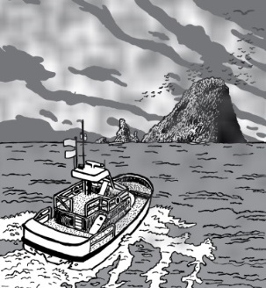
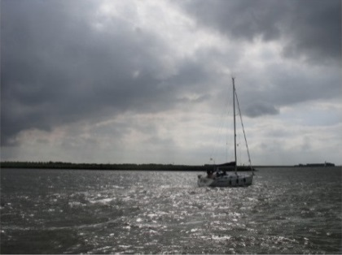
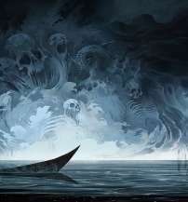
“overhead, a gray-matted sky hung like a bad omen.” P3 #TSPc1

Other weeks’ examples might include the integration of other technologies too, here is a list of some of the possible twitter/technology enriched novel study ideas that I came up with!
- Use Voki or other avatar makers to create a short character “sketch” of a main character. Have the avatar “introduce” themselves (eg. Where they are from, family, likes and dislikes, etc) using dialogue that suits that character’s personality. Tweet it out saying “Meet the character ___”
- Tweet out links of “online readings” of the chapter that was read in class today so that students can listen online if they don’t like to read, need to review, or if they missed class.
- Use a website like toondo to create a short comic strip showing how two characters would react in a given situation – their dialogue should match their personalities and be consistent with the text. It should demonstrate the relationship or conflict between the 2 characters. Tweet them out so we can compare them in class.
- Write your prediction for what will happen next – retweet other predictions that you think are also possible.
- Find one new vocabulary word that you learned in this book – tweet the word, the page, and the definition – each student must tweet a different word.
- Make and Tweet out a goanimate or similar video animation where either the physical setting of the story or the time era has changed, show how this week’s chapter would’ve been different given this new setting.
- With a partner, make and tweet a 3 minute video explanation of a significant piece of symbolism that you studied in this book.
- The main characters reaction to (problem X) was (this)…. Tweet a quote of how character (b) would’ve reacted in this same situation.
- keep an ongoing “fakebook” account for the main characters in groups – near the end of the novel, post these to twitter so that students can access “profiles” of characters, relationships, and developments in character.
- Tweet an “exit slip tweet” about something new you learned today or a question you still have.
- Have an ongoing timeline on a site such as dipity that highlights the MOST significant thing in each chapter. – each kid tweets their timeline after the final chapter.
- Have students create a short vine representing the climax or the conflict of the story – tweet them out and ask people to guess what book it is from.
- Write a blog comparing the emotions of one character to a similar experience that you’ve had – tweet out your blog asking others who have had similar experiences to comment on it.
- In groups – kids create a trailer for the movie of this book – highlighting the important parts of the story without giving the ending away – attach them to a tweet that tries to intrigue readers to watch it.
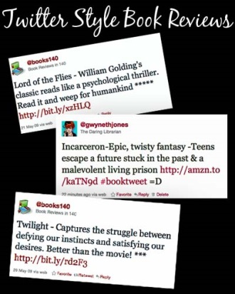
- Teacher can post an instructional video if they wish to do a “flipped classroom” activity one day – eg. If they want kids to have one class to create a video, voice recording, or any of the activities on this brainstorming list- they can give the assignment over twitter first and then let the kids work in class instead.
- After the novel has been read – watch the movie version and have kids tweet out major differences they notice in plot or quotes throughout the duration of the movie so they can be discussed afterwards without having to disrupt the flow of the movie.
- Tweet out a book review in the 140 characters that makes people want to go out and buy the book. – have to avoid wordiness and can’t give away plot! Idea from: http://www.thedaringlibrarian.com/2011/05/twitter-style-book-reviews.html

Here were just a few of some of the SLOS that I pulled from the grade 9 curriculum that I think could easily be met by some of the above suggestions if they were set up right (assignments I listed above would be like the application of knowledge from in-class discussions about the following topics):

- identify and discuss theme and point of view in oral, print and other media texts
- relate the themes, emotions and experiences portrayed in oral, print and other media texts to issues of personal interest or significance
- discuss character development in terms of consistency of behaviour and plausibility of change
- compare the development of character, plot and theme in two oral, print or other media texts
- identify ways that a change in narrator might affect the overall meaning of oral, print and other media texts

Rationale for Using Twitter: (explanation of why Twitter is the tool of choice)

The main reason why I would choose to do this “ongoing class online portfolio” through Twitter is so that all of these posts are in one organized place where students can easily review all the threads by chapter before studying for a test. I would still use in-class discussions and lectures to deliver the main points, but use twitter to showcase the material that we have learned, to keep class discussions active between classes, and for reviewing purposes. I would also use twitter during some class discussions or during movies so that the kids could respond to each other in live-time or while other things are going on. It would also be helpful to look back when we are partway through the text to see how characters have changed from the beginning, or how close our predictions were, etc. Twitter would also be a great ‘home base’ for students to be able to experiment with many other forms of technology that they can then link back to twitter so that everything is in one place. It is important that students learn how to use technology to communicate their ideas, because this is the world they are growing up in! It is also nice that twitter goes out into the real world and would create the possibility for exciting members of the online community to engage with your class (for example, what if the author of your novel started following or commenting!?) I think Twitter would especially be useful given that I chose the grade 9 curriculum, because this is a hard age to keep students engaged and excited about reading novels. I think that if you could find a way to incorporate many of the awesome technological tools out there, then they would be less reluctant to participate in the weekly assignments. It is important that by linking back to Twitter, it allows you still have all the assignments linked back to that one place that everyone can easily access (instead of having to click through numerous classmates blogs, or to keep going to different websites to view each person’s assignment.)
I would also choose twitter for this “enhanced novel study” so that I can use the convenience of tweetdeck. Tweetdeck would be handy so that the teacher can make a “list/group” of all of their students, and also to show the feeds from our different chapters to compare them side by side. For example, if we had done a character analysis project in ch.2, then again in ch. 6, I could pull up both of those twitter feeds on the smartboard and engage in a conversation about how our character has grown or changed from our first set of tweets. I would encourage students to use the tweetdeck to do the same while they were studying so that they can have all of the chapters’ reviews pulled up simultaneously!
Basically, I’m not arguing that I would use twitter for every part of a novel study, but this assignment has really opened up my eyes to how much you really could do by utilizing twitter for in your class! Hope my brainstorming has sparked some tech-saavy ideas for you too!

Photos Retrieved Sept 28th from google Images
Book examples from:
Mikaelsen, Ben. Touching Spirit Bear. New York: HarperCollins Publishers, 2001. Print.

