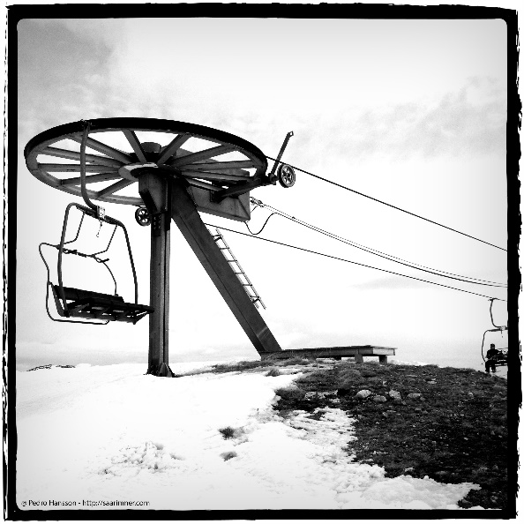
Building a Ski Lift
A chairlift is basically a looping steel cable with a large pulley at each end. Carriers (the chairs) are hung from the cable and held in place with a clamp. The clamp is tightened around the cable to keep the chair from sliding around.
Discuss the following things as a group:
- Has everyone been on a ski lift before?
- Did you notice that the chairs coming back the other way are usually empty and facing the other way? Why is that?
- What happens if you DON’T get off the chair lift when it is time to unload?
- How is a chair lift similar to a clothesline (for drying clothes)?

Materials:
- Mini ski lift = block of wood, 2 nails, 2 clear spools, linkages of elastic bands, 1 yellow “travelling” paperclip, 1 blue “cranking” paperclip
- One “Making a ski lift” handout per student
- BIG ski lift = 2 large spools, large amount of string, one skier/ paperclip per child.
Study the mini-ski lift:
- See if you can get the yellow paper clip from one clear spool to the other by ONLY rotating the blue paper clip around the wheel. (Let each member of the team try this out.)
- Fill in the first half of your worksheet

Making a big ski lift:
- Each member can color one skier. Cut them out along the dotted line.
- Use the big white spools as the “end pulleys” for your ski lift.
- Put the big wooden rods through the white pulleys and have two team members hold those spools while standing about 2 desks away from each other.
- Have one team member wrap a loop of string from one pulley to other and tie them together.
- Have the people holding the spools adjust their distance from each other so that the string pulls tight.
- Attach the skiers to the string with a paperclip. See if you can get all of the skiers from one end of the lift to the other!
Fill in the rest of your worksheet and evaluate your ski lift.

Making a Ski Lift NAME: _______________________________
Draw a diagram of the Mini- Ski Lift below. LABEL the following parts: Wooden block, nails, “crank”, “travelling” paper clip, linked elastic bands.

Labelled Diagram of the BIG ski lift: LABEL the following parts – Pulleys, Skiers, rods, “Cable” (string)

What worked well? _____________________________________________________________________ _____________________________________________________________________________________ ____________________________________________________________________________________.
Is there anything that make it work better? ________________________________________________ ____________________________________________________________________________________ ___________________________________________________________________________________.
Which of the 8 evaluation CRITERIA do you think is most important for a ski lift and why? ___________ _________________________________________________________________________________.

