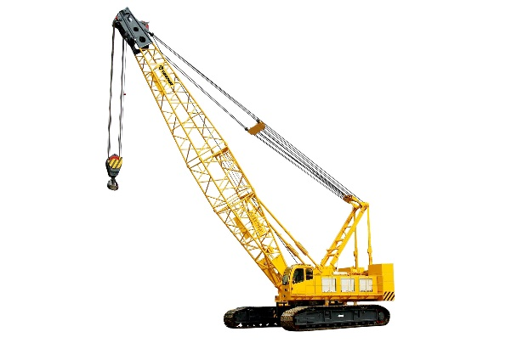
Making a Crane

A crane is a tower that is equipped with cables and pulleys that can be used both to lift and lower materials and to shift them from side to side.
Discuss the following questions:
- Where have you seen cranes before?
- What types of things are they used to carry?
As a group you are to make a crane that cranks up and down. Your goal is to follow the directions perfectly so that you make the SAME crane as you see in the picture.
MATERIALS:
- REFERENCE PICTURES– There should be a full page with printed out pictures of the steps– this is what you need to look at to make sure you are connecting the crane correctly.
- String, bucket, and pennies – (cable and load)
- Big box – (body of the crane)
- Cardboard arm (crane arm)
- Crank (white circle with a stick glued on it)
- 3 brass fasteners
- Brass fastener and round metal washer (to hold the white crank in place)
- Clear spool and a red unfolded paperclip – to hold the top pulley onto the frame
- Something heavy to put in the big box to hold down the crank (a counterweight)
- One “Making a Crane” worksheet per student.
Procedure:
- Place the big freezie box on a table. Make sure that the open end is facing up towards the ceiling. Use 2 brass fasteners to attach the long cardboard arm by putting brass fasteners through the holes 1 and 3 on the arm, through the matching holes in the freezie box, and then open the ends of the brass fasteners inside the box so that it keeps the arm in place. (HINT the holes should line up with the spots on the box.)
- Put the last brass fastener through the metal washer, and then through the hole in the white crank so that the handle is facing outwards from the box. Fasten it to the box by opening up the 2 prongs inside the box.
- Fasten the clear spool to the box by threading it through an unfolded paperclip. This spool should go on the very TOP hole of the crank. One flat side of the spool should lay against the box while the other side faces out.
- Unravel the string from the white crank, and pull it up over the TOP small pulley so that it hangs down from the top of the crank to the floor. The bucket should be touching the ground.
- Put something heavy (such as a dictionary) in the box as a counterweight.
- Try cranking the white wheel without anything in the bucket. (Let each group member try)
- Slowly add 10 pennies at a time and see if it gets harder as weight is added.
- Fill out the “Making a crane” worksheet.

Making a Crane NAME: __________________________________
What is the purpose of a crane? _________________________________________________________ ____________________________________________________________________________________.
List the materials that you used: __________________________________________________________ ____________________________________________________________________________________ ____________________________________________________________________________________.
Summarize the procedure that you followed to build the crane: _________________________________ _____________________________________________________________________________________ ________________________________________________________________________________________________________________________________________________________________________________________________________________________________________________________________________________________________________________________________________________________________________________________________________________________________________.
Label the following parts on this drawing of your crane:
BODY ARM CRANK CABLE COUNTERWEIGHT PULLEY BASKET

PICTURE REFERENCES
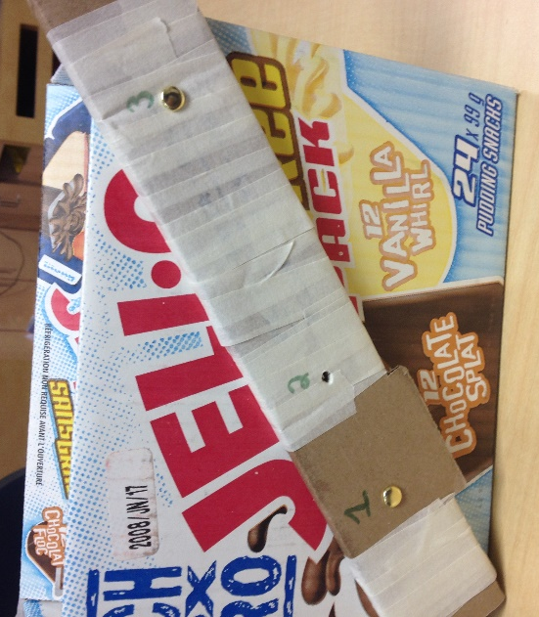  - Fasten holes 1 and 3 into their holes in the box using brass fasteners. | - Put the last brass fastener through the silver washer, and then through the white crank, and through hole 2 on the arm and box.  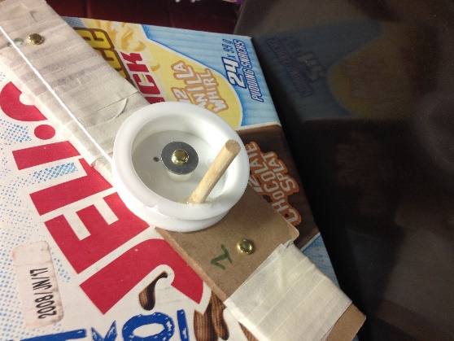
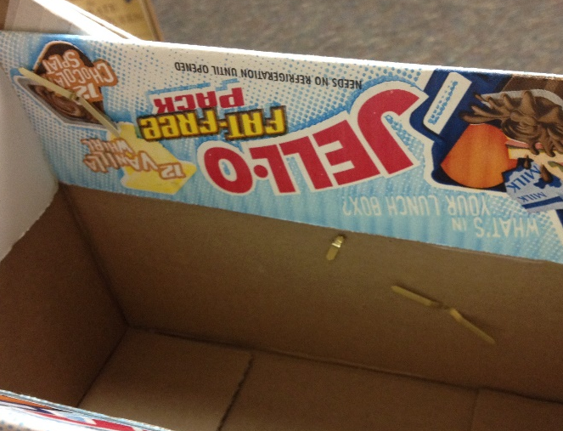  This is what the inside of the box should look like – all 3 brass fasteners should be opened up. To secure the arm and crank from the inside. | - Put the clear spool through an opened paperclip near hole #4. Hook the paperclip around the cardboard arm so that it holds the spool in place. Thread the string over the TOP of the spool like shown here (step 4)
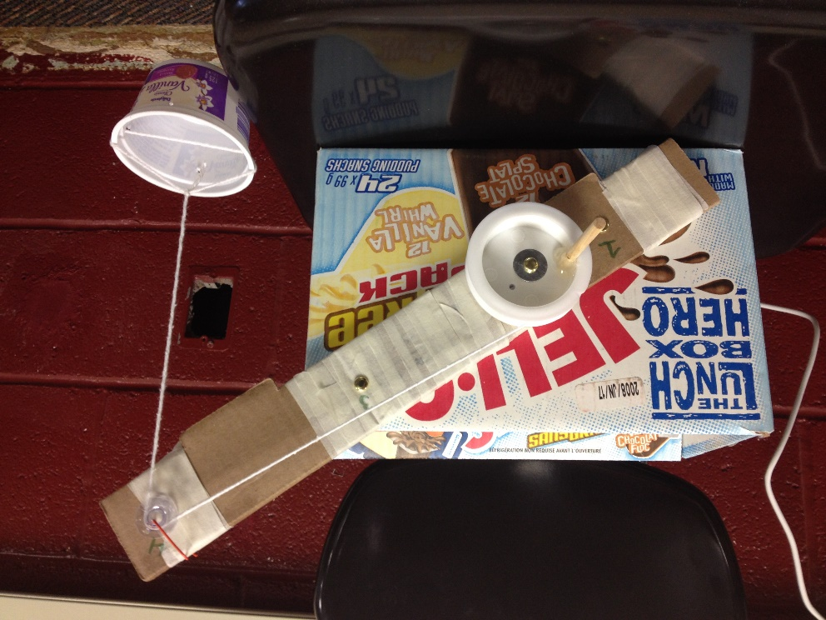
THIS is what your crane should look like in the end.

