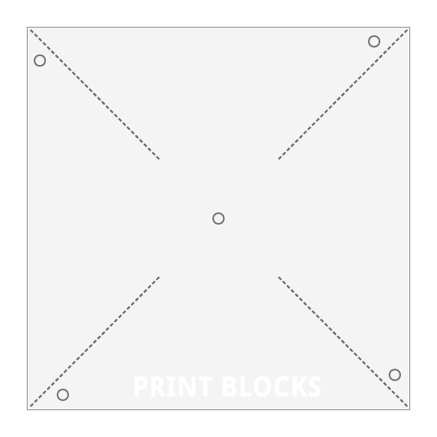
PINWHEEL TEMPLATE

How to make a Pinwheel (Windmill)
Read pages 13 and 14 from your Mini-Textbook as a group. Discuss the following questions:
- What are some advantages of using the wind as a source of power?
- What might be a disadvantage of using wind as a source of power?
- How were the first windmills different from the later ones (in Europe?)
- What types of things are windmills used for?
You will need the following materials:
- A pencil WITH AN ERASER
- Scissors
- Each kid needs one copy of the “Pinwheel Template”
- Each kid needs one copy of the “Evaluate your Pinwheel” sheet
- One pin per kid
- Mini-textbooks

- Each kid gets one piece of paper that has the square on it. Start by cutting out the big square.
- Next, cut along each dotted line from the corners towards the middle, STOPPING when the line ends.
- Grab each corner that has a circle on it and bring that dot to the middle dot DO NOT FOLD your paper, just let it curve.
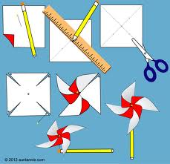
- Once all 4 “dots” are at the middle dot you can get one of the pins and poke it through all 4 tips, then flip the pinwheel over to make sure that your pin gets poked through the MIDDLE of the back side of the pinwheel as well.
- Poke the pin into the eraser of your pencil.
- Blow on the windmill to make it move.
- Each student should fill out the first column in the “Evaluate your Pinwheel” Sheet.
- How can you improve your windmill to make it turn more easily? (HINT look at other materials that I have provided for you.)
- Finish the rest of the worksheet. For question #2, use pages 10 and 11 from your textbook to help you answer the questions. When your worksheet is COMPLETELY finished, you may take apart your pinwheel and color it/ make designs on it.
- You may keep your pinwheel parts as long as they go in your backpacks right after science so you don’t play with them in class.

