Fur Trade Background Information:
The fur trade depended upon the Aboriginal people, who imposed their trading practices and commercial requirements on the Europeans. To win the Aboriginals as clients, the Europeans had to manufacture goods of value to the Indian culture. Indians negotiated with merchants from the various trading posts, from New England and from the Hudson's Bay Company. The merchants were all in strong competition with each other and so, to secure the assistance and cooperation of the Aboriginals, they offered gifts to the Indians. Smoking the ceremonial pipe and exchanging gifts before commencement of trade was an ancient Aboriginal tradition. Europeans participated in the custom as well.
In order to be successful as voyageurs and fur traders, the Europeans
- Learned to use Aboriginals’ ways of travel (e.g. canoe, snowshoe)
- Used Aboriginal trade routes and knowledge of the land
- Learned medical knowledge from Aboriginals
- Learned other survival knowledge, such as food gathering and hunting from the Aboriginals

The hides and furs exported to Europe were used to make luxury items, mainly beaver hats. The Aboriginal person’s goal was to trade for useful items. On average 60% of the trade goods they received were fabrics, 25% were weapons and tools, 6% alcohol, 3% trade jewelry, and 2% tobacco.
The meeting of two civilizations always involves an exchange of ideas, objects and ways of doing things that are later adapted to the tastes and needs of each culture. The Europeans adopted Aboriginal customs and inventions essential for survival in the North American wilderness. The Aboriginals utilized European articles and integrated them into their own culture, often giving them a function completely different from that intended by the manufacturers. They quickly began to use beads, guns, cooking pots, horses and fabrics that the Europeans supplied.
Game Setup:
Trading posts – HBC against the NWC. If you are at a trading post it is your duty to read the chart of “goods” and prices and try to make a deal with the natives. Your goal is to gather as many furs as possible, and to convince natives to come to YOU for business instead of going to the other trading post. You can collect ‘furs’ by either exchanging them for goods, or by trading them for “Made Beaver Tokens”.
Natives – You need to take into consideration what types of things your tribe needs for survival (survival card). Your role is to ‘hunt’ for furs, travel to the trading posts, and try to get as many goods as possible for your tribe by trading your furs for the best deal. You have to be strategic about whether you want to give away all of your furs, try to make a deal with either of the trading posts, or exchange furs for ‘tokens’ for a later use.
Voyageurs – Your job is to travel from your company’s trading post back to Europe with all of the furs collected. You must carry your canoe during your journey. You start in Europe, gather ‘goods’, and take them back to the new world (to your trading post). Then you will unload your European ‘goods’, load the native furs onto your canoe, and transport them back to the mother country.

“Standard of Trade” Chart
European Goods  (and amount) | Amount of Beaver Pelts
1 Axe | 2
100 Beads | 1
100 Bullets | 1
1 Cooking pot/ pan | 2
1 m. Fabric | 2
20 Fishing hooks | 1
1 pb. Gunpowder | 2
1 Gun | 6
2 Knives | 2
Measuring cups | 1
10 Needles | 3
3 m. Rope | 2
2 Scissors | 1
2 Scrapers (wood or metal) | 2
1 Shoes (pair of) | 1
3 Soup ladles | 1
10 spoons | 1
String (roll) | 1
Sugar | 1
Wool (point) blankets | 4

Beaver Pelts Other Animal Pelts
1 beaver pelt (or another animal fur that equals 1 beaver pelt) can also be exchanged for “Made Beaver Tokens” to be used more like money.
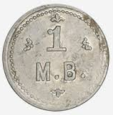=
1 equals... 2 otters
1 equals... 2 foxes
1 equals... 1 wolf
2 equals... 1 moose
1 equals... 1 black bear
1 equals... 2 deer
1 equals… 1 buffalo

Tribal Request Card | Tribal Request Card | Tribal Request Card
Tribal Request Card | Tribal Request Card | Tribal Request Card
Tribal Request Card | Tribal Request Card | Tribal Request Card
Tribal Request Card | Tribal Request Card | Tribal Request Card

Your tribe needs new clothing, and they want to make new ceremonial clothing.  You will need things such as fabric and beads. | Your tribe needs some supplies for eating.  They are asking for things such as cooking pots/ pans, measuring cups, and soup spoons. | Your tribe has reason to believe that they will be in battle with another tribe soon.  You should buy supplies such as guns, gunpowder, and bullets.
Your tribe would like to fix some of their old clothing. They are asking for string and needles. | It is spring and the fish are plentiful. Your tribe is asking for fishing hooks and knives. | Your tribe is asking you to get them some spoons and sugar.
Winter has been long and cold. Your tribe needs some blankets! | The Europeans have shown you many things that you would like to build. Buy rope and scissors for your tribe. | A rocky migration has left many of your families needing new shoes. Buy at least 3 pairs
Your tribe would like a few axes to help cut down teepee trees more easily. | Your tribe would like a few scrapers to make it easier to prepare buffalo hides. | Your tribe would like some knives to make life easier for themselves!

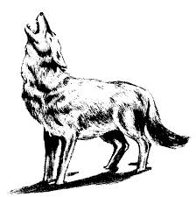  Wolf | Wolf | Wolf | Wolf
Wolf | Wolf | Wolf | Wolf
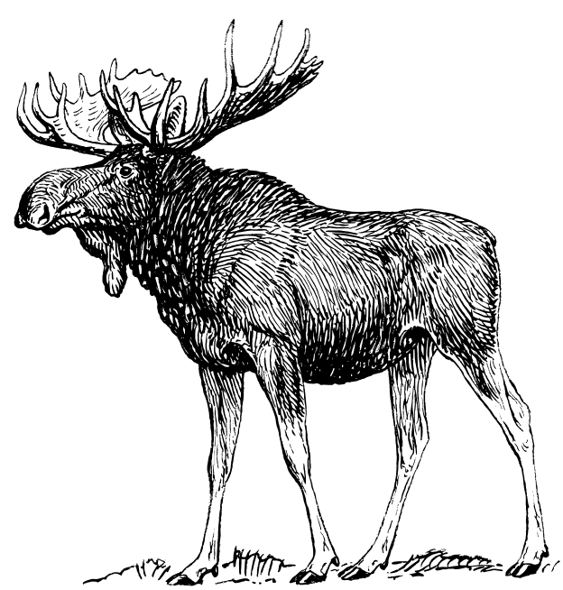  Moose | Moose | Moose | Moose
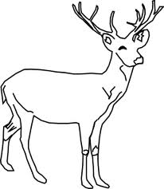  deer | deer | deer | deer
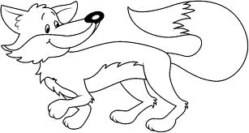  fox | fox | fox | fox
fox | fox | fox | fox

Back bear  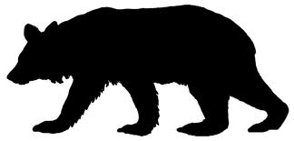 | Back bear | Back bear | Back bear
Back bear | Back bear | Back bear | Back bear
Otter  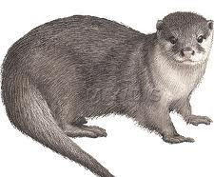 | Otter | Otter | Otter
Otter | Otter | Otter | Otter
Buffalo  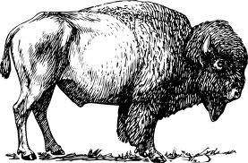 | Buffalo | Buffalo | Buffalo
Buffalo | Buffalo | Buffalo | Buffalo

1 Axe | 1 Axe | 1 Axe | 1 Axe
100 Beads | 100 Beads | 100 Beads | 100 Beads
100 Bullets | 100 Bullets | 100 Bullets | 100 Bullets
1 Cooking pot/ pan | 1 Cooking pot/ pan | 1 Cooking pot/ pan | 1 Cooking pot/ pan
1 m. Fabric | 1 m. Fabric | 1 m. Fabric | 1 m. Fabric
20 Fishing hooks | 20 Fishing hooks | 20 Fishing hooks | 20 Fishing hooks
1 pb. Gunpowder | 1 pb. Gunpowder | 1 pb. Gunpowder | 1 pb. Gunpowder
1 Gun | 1 Gun | 1 Gun | 1 Gun
2 Knives | 2 Knives | 2 Knives | 2 Knives
Measuring cups | Measuring cups | Measuring cups | Measuring cups
10 Needles | 10 Needles | 10 Needles | 10 Needles
3 m. Rope | 3 m. Rope | 3 m. Rope | 3 m. Rope
2 Scissors | 2 Scissors | 2 Scissors | 2 Scissors
2 Scrapers (wood or metal) | 2 Scrapers (wood or metal) | 2 Scrapers (wood or metal) | 2 Scrapers (wood or metal)
1 Shoes (pair of) | 1 Shoes (pair of) | 1 Shoes (pair of) | 1 Shoes (pair of)
3 Soup ladles | 3 Soup ladles | 3 Soup ladles | 3 Soup ladles
10 spoons | 10 spoons | 10 spoons | 10 spoons
String (roll) | String (roll) | String (roll) | String (roll)
Sugar | Sugar | Sugar | Sugar
Wool (point) blankets | Wool (point) blankets | Wool (point) blankets | Wool (point) blankets

